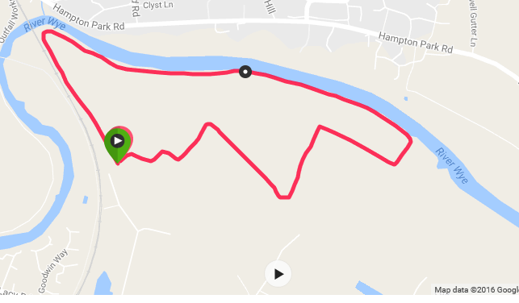

Race 1 at Rotherwas on the 14th June, the race starts at 7.30pm

Rotherwas Course:

All adults will do 2.5 laps of the fast and flat 2 mile course, junior runners will do 1.5 laps of the course. The route uses footpaths and permitted routes around private farmland. Please stick to the course and avoid running on the crops. Please ask your spectators to keep themselves and their dogs off the crops.

Water and cake will be available for runners after the race and professional first aid cover will be on site.

Directions and Parking:

Parking will be at the Balfour Beatty yard, Thorn Business Park, Holme Lacy Road, HR2 6JT. We would like to thank Balfour Beatty for their generosity in offering us the use of their car park once again.

The car park will be signed off Holme Lacy Road.

The start of the race is on the riverbank halfway round the lap (see the black circle on the above picture) and is a good 15-20 minute walk from the car park. There are toilets near the finish of the course, so please use these rather than those in the Balfour Beatty yard.

If you are coming by bike or by foot, please follow the greenway bridge over the river from the city and the paths towards Rotherwas. There will be space to secure your bike.

We are looking forward to seeing all your runners on the 14th.

