HEREFORDSHIRE WINTER OFF-ROAD LEAGUE

BUILTH & DISTRICT RUNNING CLUB

RACE 1 - FFOREST FIELDS

SUNDAY 18TH OCTOBER 2015 - 11AM START
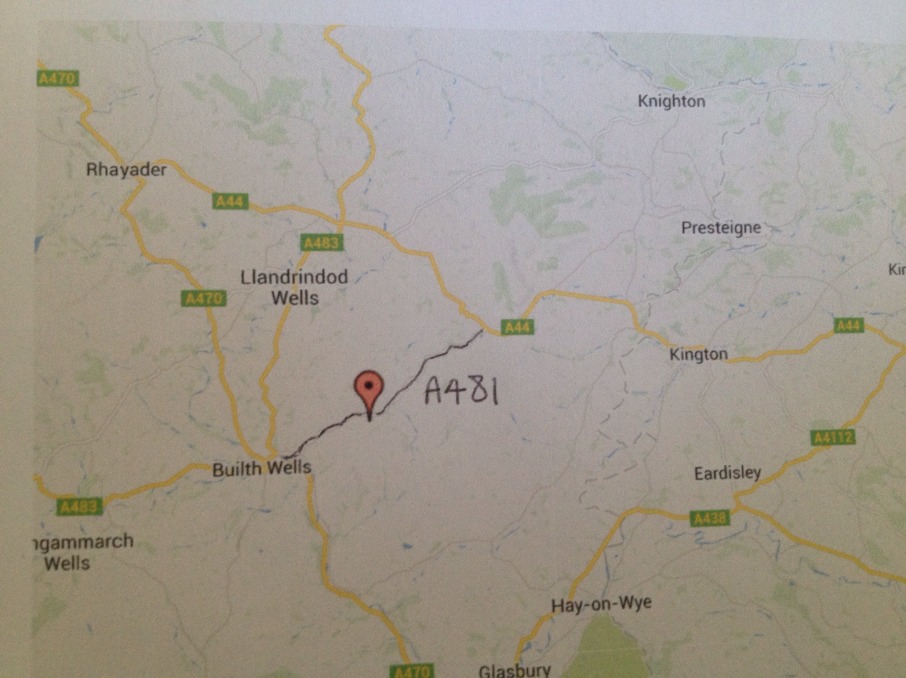

If approaching from Kington take A44 then A481 (Fforest Inn) towards Builth Wells. Fforest Fields campsite is signposted on the left just under a mile from the village of Hundred House.

From Builth pass through the town, take 2nd exit onto A483 towards Llandrindod, then take first right onto A481, Fforest Fields campsite is a few miles down the road on the right and is signposted.

No postcode included as this will take you to the wrong place.

At Fforest Fields Campsite please drive slowly and please park on the gravel
Thank You!

HEREFORDSHIRE WINTER OFF-ROAD LEAGUE

BUILTH & DISTRICT RUNNING CLUB

RACE 1 - FFOREST FIELDS

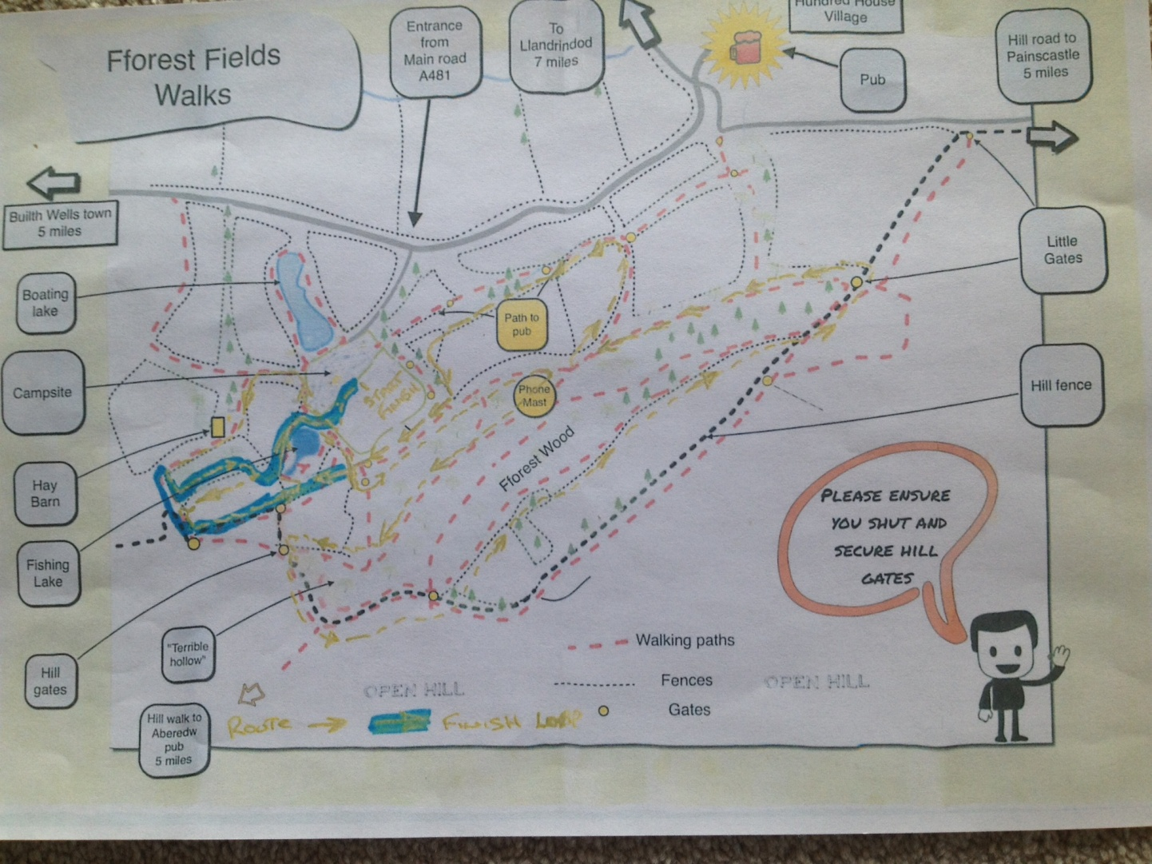
SUNDAY 18TH OCTOBER 2015 - 11AM START

Approx 9.7k, one lap, farm tracks, woodland, total climb approx 158m, max elevation 375m

Refreshments for all runners after the race.

